https://www.lemonde.fr/en/economy/article/2026/01/30/french-economy-grew-slightly-more-than-expected-in-2025_6749963_19.html

France's economy grew slightly more than expected in 2025
The country's gross domestic product rose by 0.9% in 2025, with 0.2% growth in the fourth quarter, the national statistics agency said on Friday.
By Béatrice Madeline
Published on January 30, 2026, at 11:49 am (Paris), updated on January 30, 2026, at 12:25 pm
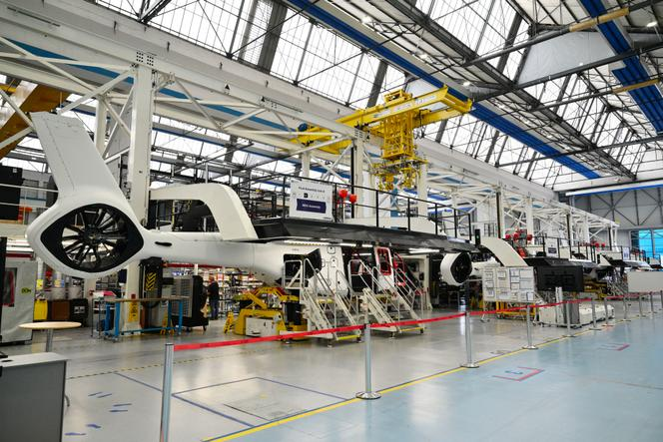 A final assembly line for Airbus H160 helicopters, at Airbus Helicopters' facility in the Mediterranean coastal town of Marignane, on July 24, 2025."> A final assembly line for Airbus H160 helicopters, at Airbus Helicopters' facility in the Mediterranean coastal town of Marignane, on July 24, 2025. CHRISTOPHE SIMON/AFP
In the end, France's 2025 economic growth exceeded expectations, albeit only slightly. The economy grew by 0.9% in 2025, despite political and international instability, budgetary uncertainty, and a slowdown in gross domestic product (GDP) growth in the fourth quarter compared to the year before (+0.2% versus +0.5%), according to figures published by the National Institute of Statistics and Economic Studies (INSEE) on Friday, January 30. That was slightly higher than the 0.7% growth initially forecast, but still below the 1.1% and 1.6% growth rates achieved in 2024 and 2023, respectively.
Paradoxically, despite the imposition of American tariffs and their impacts on global trade, French growth was driven by foreign trade in 2025, contrary to the two previous years, according to Marie Leclair, head of INSEE's national accounts department. Exports were particularly strong over the last two quarters of the year, boosted mainly by the aerospace, shipbuilding and digital services sectors.
"It seems that French industrial companies went out and secured orders abroad," said Mathieu Plane, an economist at the French Economic Observatory (OFCE). Industrial firms also reaped the benefits of military rearmament efforts underway throughout Europe and of the German stimulus plan, which has benefited French manufacturers that supply industrial inputs and intermediate goods.
The defense industry's revival also stimulated companies' investments, along with falling interest rates that made it easier to access funding. This investment surge, which had been a positive surprise in the third quarter, was confirmed in the fourth, as the overall growth in investment by non-financial companies over the period was higher than predicted, going from 0.8% to 1%.

Households remain cautious
Household investment, which, in practice, means new home purchases, also saw an upward trend, going from a predicted -0.1% to +0.4%, in line with the real estate market's recovery. On the other hand, the fourth quarter saw a slowdown in investment, at only +0.2%, notably linked to the construction sector. Yet, overall in 2025, that sector of the economy turned positive again, after a poor year in 2024 (+0.2%, after -1.3% in 2024). The rise of artificial intelligence likely spurred companies to purchase software and other digital services, with results that herald an acceleration for French businesses in this sector. Companies also significantly invested in legal, accounting and technical services, which saw a 5% increase in 2025.
While exports of goods were strong, imports fell sharply at the end of the year. One explanation is that companies had built up substantial inventories over the first months of 2025 and relied more on these existing stocks than on new imports in the second half of the year.
The other explanation is more concerning: It suggests that lower imports reflect weak household consumption, with consumers still being anxious about rising unemployment rates and possible tax increases. Over the year, consumption of goods and services grew by only 0.4%, a much lower figure than in 2024 – a year which, it must be said, experienced an economic boost from the Paris Olympic Games, through ticket sales, transport services, hotels and restaurants.
Nevertheless, French households stayed prudent in their spending over 2025. This caution appeared stronger toward the end of the year amid the budget debate: In December, goods consumption dropped by 0.6%, after a 0.3% decline in November. Food spending, which had decreased during the inflation crisis, reported discouragingly stable levels over the year, much like energy spending.
The current low level of inflation and the 2026 budget, which is less restrictive than had been feared, could prompt French consumers to open their wallets more in 2026. "Consumption, which is essential, as it represents half of the country's economic activity, could slowly return to an average annual growth rate of 1%, thanks to wage increases that now outpace inflation," said Stéphane Colliac, an economist at BNP Paribas.
Will this potential recovery in consumption drive growth in 2026? For now, INSEE has estimated that a 1% increase in GDP will already be secured by mid-year, as does France's central bank, the Banque de France. The final adoption of the 2026 budget bill, expected on Monday, February 2, could reduce the uncertainty that has prevailed among businesses and households since the 2024 dissolution of the Assemblée Nationale. Assuming, however, that global geopolitical instability and trade policy turbulence do not derail everything.

