https://www.lemonde.fr/en/economy/article/2025/05/01/why-french-executives-lead-so-many-foreign-corporate-giants_6740810_19.html

Why French executives lead so many foreign corporate giants
French nationals head about 30 major foreign companies whose total market capitalization amounts to $2 trillion. This phenomenon highlights both the success of French managerial training and a brain drain.
By Sophie Fay
Published yesterday at 8:00 pm (Paris)
6 min read
Lire en français
Share
- Share on Messenger
- Share on Facebook
- Share by email
- Share on Linkedin
- Copy link
Subscribers only
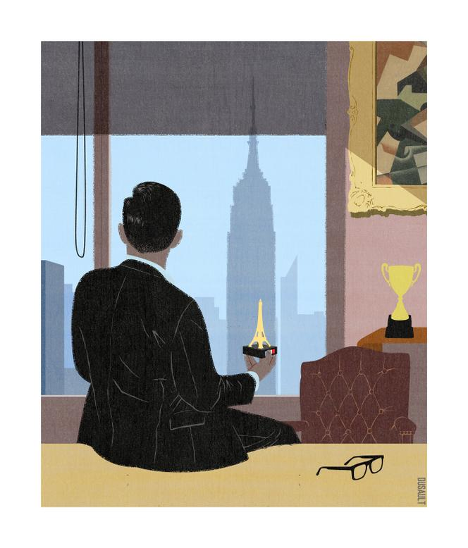 <img src="https://img.lemde.fr/2025/04/28/0/0/2693/3154/664/0/75/0/6680370_sirius-fs-upload-1-ppz5lzci2fzz-1745883889576-dessin-patronsfrancais-ecoetentreprises-themonde.jpg" alt=""> ANTOINE MOREAU DUSAULT
It's a $2 trillion (nearly €1.8 trillion) riddle. Since April 23, Marguerite Bérard, 47, former head of the bank BNP Paribas's branch network, has been leading the Dutch bank ABN Amro. What is the common thread between this institution and the 30 groups we're about to list?
Let's begin with six iconic American brands: Estée Lauder, Ralph Lauren, Tory Burch, Michael Kors, Neutrogena and the department store chain Bloomingdale's. Add seven pharmaceutical champions: AstraZeneca, UCB, LEO Pharma, Takeda, Moderna, Kenvue and Incyte. Continue with the German Nivea-Beiersdorf, Swiss Nestlé, Italian insurer Generali, Belgian military and industrial equipment manufacturer John Cockerill, Swiss temporary work agency Adecco, British retail group Kingfisher, Chinese JD Sport, Finnish elevator and escalator company Kone and the Dutch company ASML, without which no European electronic microchips would ever be printed. Let's also mention two well-known tech companies: Expedia, which runs online travel agencies (including Hotels.com and Vrbo), and Instacart, the leading grocery delivery service in the United States. Finally, several "unicorns" (start-ups valued at over 1 billion dollars or euros): Datadog, Snowflake, F5, Front, Upgrade, Hugging Face, Deel and more.
What these companies have in common is very simple: All of them have French CEOs. These include Ariane Gorin at Expedia, Christophe Fouquet for ASML, Fidji Simo at Instacart and Laurent Freixe with Nestlé. We could add French-Moroccan dual national Ilham Kadri, who was trained in France and is the CEO of materials specialist Syensqo, which was spun off from the French-Belgian chemical group Solvay and proudly proclaims its French touch.
Read more Subscribers only What do France's top companies contribute to the national economy?
French leaders at foreign companies are not a rarity. Matthieu Courtecuisse, 51, the founder of consulting firm Sia Partners, has identified more than 30 such cases, a phenomenon unmatched by other nationalities. He himself leads, from New York, a unicorn comprised of 3,000 consultants, including 350 data scientists, with €500 million in revenue. One of its subsidiaries is dedicated to developing molecules for pharmaceutical companies. "In recent years," he told Le Monde, "an international 'shadow CAC 40' [the French stock market index] has formed, made up of foreign companies, all leaders in their markets. The total valuations of these French-led companies amount to $2 trillion, which is roughly the total current capitalization of all of the companies that make up the CAC 40." The CAC 40, incidentally, includes six foreign CEOs.

Tip of the iceberg
Should we celebrate the tremendous success of French business schools or, conversely, worry about a form of brain drain? Courtecuisse clearly leans toward the brain drain view. As he saw it, the list of French CEOs abroad was just the tip of the iceberg. He noted that "American biology or artificial intelligence is teeming with French PhDs." He believes that "the 'de-talentization' movement over the past 25 years has occurred as mirror to France's deindustrialization." Unlike India, which has turned the export of its tech stars into a showcase for the country's assets, France has no real strategy. The consultant noted that French individuals who lead major foreign groups mostly left the country 20 years ago. "If we project 15 or 20 years ahead, there will be even more, as the departure of young graduates is even stronger," he said. Yet no one – except perhaps Donald Trump – seems able to stop it.
Read more Subscribers only France's CAC 40 companies register billions of euros in profits and dividends in record year
Is the existence of this managerial French touch – just like there was a French touch among DJs in the 1990s – such bad news for the country? There are almost as many opinions on the matter as there are expatriate executives, given how different their backgrounds are. One sector stands out, however: pharmaceuticals, with a paradox. There are French nationals at the helms of several American start-ups (such as Moderna and Incyte) as well as multinationals, including the Swedish-British company AstraZeneca, the Japanese Takeda, the Belgian UCB, the American Kenvue and the Danish LEO Pharma, but the CEO of the French pharmaceutical champion Sanofi, Paul Hudson, is British.
Help us improve Le Monde in English

Dear reader,
We’d love to hear your thoughts on Le Monde in English! Take this quick survey to help us improve it for you.
Take the survey

Hervé Hoppenot left France 30 years ago to work for Aventis and has been CEO of Incyte, the biotech company that discovered a treatment for vitiligo, since 2014. Listed on the Nasdaq, it is valued at $11.5 billion. Hoppenot offered two explanations for the phenomenon. First, "in the US or China, there's a belief in the benefits of progress, that new technologies will solve the world's major problems. Europe is more nostalgic." Secondly, it's about capital: "Incyte took 15 years before seeing its first return on investment: It requires investors who can support that." The US has them, with a well-oiled system that creates wealth unmatched in Europe.

An asset in their roles
Some members of this "shadow CAC 40" consider their nationality to be a secondary factor, at least professionally. Laurent Freixe, 63, who's been CEO of the Swiss multinational Nestlé since September 1, 2024, describes himself as first and foremost "a pure product of Nestlé meritocracy." Christophe Fouquet, 51, the head of ASML, a supplier of cutting-edge machines for the semiconductor industry (€300 million each) and the fifth-largest company by market capitalization in Europe, prefers to present himself as a European.
Others view their pedigree as an asset in their roles. "The French engineer is quite a generalist athlete: They have the tools to reason and make decisions, which applies well to leadership positions," said François Locoh-Donou, the French-Togolese founder of F5, which provides security for apps on phones, computers and in the cloud. Listed on Nasdaq, this Seattle-based company is valued at $15 billion.
Also based in Seattle, Ariane Gorin, CEO of Expedia (with a market capitalization of $20 billion), believes there is a French flair to management. Raised in California, in a French family, she moved to Paris at 27. There, she discovered "the very structured French approach: We look at the facts, make hypotheses, then strategize. The tenacity: We work hard, the 35-hour workweek doesn't exist at a high level. And the subtlety: At lunches, you need to know how to talk about everything. My 13 years in France made me a better leader," she asserted, proud of having benefited from two proper maternity leaves in France.

Less uniform career paths
Gorin, Locoh-Donou and Kadri of Syensqo noted that American companies were more open to less-typical profiles. Locoh-Donou, an engineer, was sent as a national service volunteer in the R&D department of a French company, which, later, did not want to let him switch to its commercial side. He made the transition in an American company, instead. "There's less risk-taking among the French," he lamented. He also felt that his "mixed-race side," as he put it, would never be an issue, something which wasn't certain in France. Gorin further noted that the career paths of leaders in the US are much less uniform than they are in France: "When I meet other CEOs at conferences where I speak, I don't feel like they've all known each other for 30 years," she explained. This is, indeed, often the case in Paris.
Clément Delangue, co-founder of the AI tool publication platform Hugging Face, is also a defender of the French touch. His unicorn – created eight years ago and valued at $4.5 billion in its last funding round, in the summer of 2023 – has the same number of employees (230) on each side of the Atlantic. Based in Miami, he wants to be a bridge between the two worlds to benefit "from the ambition, resources and optimism of the US, and the rigor and technical qualities of France." He is pleased that Hugging Face had the ability to bring Tesla's robotics specialist, Remi Cadene, back to France.
Read more Subscribers only Macron boasts France is 'back in race' on AI
François Michel, who heads the Belgian group John Cockerill, which specializes in industrial maintenance and armament, noted, as a positive sign, that "the reputation of French companies and their management is good, better than it was 20 or 30 years ago. The fact that they are globalized also contributes to their attractiveness to executives." Indeed, many of these executives had initially been sent abroad by French companies. This was the case for Hoppenot, now at Incyte; Pascal Soriot, who was his colleague and leads AstraZeneca; and Christophe Donnet, first sent abroad for Axa and now head of the Italian insurance company Generali.

A potential identified by the Elysée
Indeed, international recruitment firms are shopping around in French companies. Olivier Bron, the 48-year-old former operations director of the Galeries Lafayette group, found himself leading a Thai company, before taking over Bloomingdale's in November 2023. Bron is only the ninth CEO in the iconic New York fashion retailer's 150-year history, with its 32 stores and 15,000 employees across the country. Moreover, he's in good company, as the head of Estée Lauder, Stéphane de La Faverie, formerly of L'Oréal, and that of Ralph Lauren, Patrice Louvet, are also French.
Is this "shadow CAC 40" good or bad for France? The French government, in any case, has clearly identified the potential of this network, which, by its nature, is rather discreet in Parisian circles. On LinkedIn, Claire Vernet-Garnier, government adviser for industry, innovation and digital affairs, is connected to almost all of them. The French diplomatic network has also often recognized them, and they are rather proud of this: In mid-March, Bron, of Bloomingdale's, was received at the French consulate, to analyze the US economic situation and the consequences of Trump's tariff increases. F5's Locoh-Donou is regularly consulted and asked to invest in France. Finally, ASML's Fouquet recruited former economy minister Bruno Le Maire as a consultant to his board of directors. This is a sign that this executive diaspora is not indifferent to its country of origin.
Read more Subscribers only Governance goes global in France's blue-chip CAC 40 index
Sophie Fay
Translation of an original article published in French on lemonde.fr; the publisher may only be liable for the French version.

