https://www.lemonde.fr/en/economy/article/2023/05/15/choose-france-summit-2023-edition-sees-record-harvest-of-foreign-investments_6026736_19.html

Choose France summit: 2023 edition sees record harvest of foreign investments
France will announce it is receiving €13 billion in foreign investments, as 200 business leaders gather Monday around Emmanuel Macron.
By Jean-Michel Bezat
Published on May 15, 2023, at 1:57 pm (Paris), updated on February 13, 2025, at 11:47 am
4 min read
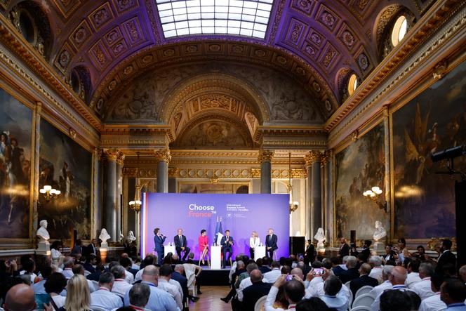 <img src="https://img.lemde.fr/2023/05/14/0/0/0/0/664/0/75/0/1df6b4a_1684107985419-000-32e94hd.jpg" alt="French President Emmanuel Macron at the fifth edition of the Choose France summit in Versailles on July 11, 2022."> French President Emmanuel Macron at the fifth edition of the Choose France summit in Versailles on July 11, 2022. LUDOVIC MARIN / AFP
The sixth edition of Choose France summit might be described as a vintage to remember, as key foreign investors gather in Versailles on Monday, May 15, in the presence of President Emmanuel Macron.
With more than 200 business leaders in attendance, the summit will be the scene of many announcements, including 28 projects, new or extended, worth a total of €13 billion euros, more than in 2022 (10.6 billion) and 2021 (3.6 billion). The foreign investments will result in 8,000 direct job creations, in particular in medium-sized cities. The scope of the announcements confirms an Ernst and Young (EY) survey published on May 12, which found that France remains the most attractive country in Europe in terms of the number of projects – if not jobs created – and in the area of research and development (R&D).
The president will not give a speech in Versailles because he already outlined his industrial policy on Thursday at the Elysée Palace and on Friday in Dunkirk, when he spoke of reindustrialization as the "mother of all battles." In an interview published Monday by L'Opinion, he attributed France's attractiveness to "clear, bold reforms and above all that we maintain them, and this despite the Yellow Vest movement crisis, despite the war, despite inflation, despite the protests." He called it "a total constancy of macroeconomic policies." In particular, he cited the decrease in corporate taxation, which is returning to the European average.
Editorial France bears the first fruits of reindustrialization
As in previous years, the president will meet face-to-face with the heads of six foreign groups: US-based Pfizer and Disney, Denmark's Novo Nordisk, Belgium's Solvay, India's Arcelor Mittal and Thailand's CP Group, a giant conglomerate active in agribusiness and retail. On Monday morning, he also met with Tesla and Twitter owner Elon Musk. He will have to reassure them because, according to EY's "Barometer of France's Attractiveness," fewer foreign executives than in previous years are optimistic about investment prospects over a three-year horizon.
For the time being, investments are in line with the "greenifying" of the economy. The Elysée emphasized that many projects are "emblematic of green reindustrialization," allowing France to "position itself at the heart of the value chain for the production of equipment in the renewable and low-carbon energy sectors, as well as for electric vehicles." Two flagship projects in Dunkirk, announced on Friday, concern electric vehicles.
Read more Subscribers only Northern France dreams of becoming Europe's battery valley

Reducing dependence on Chinese products
Taiwan's ProLogium will invest €5.2 billion by 2030 to build a factory producing solid-state batteries, an alternative technology to lithium-ion, with some 3,000 jobs at stake. Not far away, the Chinese battery materials producer XTC signed joint venture agreements with the nuclear group Orano to manufacture precursors and cathodes and for recycling. The investment will total €1.5 billion.

Another important announcement concerned the Holosolis photovoltaic solar panel factory project led by the European group InnoEnergy, which is to be built in Sarreguemines, in eastern France. The €710 million investment will create 1,700 jobs in 2027 and reduce dependence on Chinese products.
Nuclear power is also a low-carbon technology. The Italian startup Newcleo, founded in 2021 by the Turkish physicist Stefano Buono and based in the UK, is betting very heavily on France's current revival of this sector. No announcement has been made ahead of the Choose France summit, but Le Figaro reported on May 15 that the company, now campaigning to raise €1 bilion, is ready to €3 billion in France to develop SMRs – small modular reactors (up to 300 megawatts) manufactured in factories and assembled on-site in modules. Supported by the France 2030 investment plan, Newcleo has initiated discussions with the French Atomic Energy and Alternative Energies Commission, EDF and Framatome.
Automotive projects are well represented: Italy's Iveco is going to boost its sites in Annonay and Bourbon-Lancy with an investment of €115 million, while Portugal's Powerdot will invest €140 million to extend its network of electric vehicle charging stations, which will create 66 jobs.
The pharmaceutical sector is also investing. Pfizer will develop activities, including with subcontractors, mobilizing a further €500 million, coming in addition to the same amount announced in 2022. GSK will spend €400 million, in particular for the production of Ventoline (against asthma), in Evreux, Mayenne and Saint-Amand-les-Eaux. And Italian biotech company Sapio plans to spend €200 million over three years on an acquisition and an expansion of its activities, with the prospect of creating 100 jobs.

Revitalization of territories
In the telecommunications sector, Finland's Nokia, which absorbed Alcatel-Lucent in 2015, is beefing up its R&D in the towns Saclay and Lannion to develop 5G and 6G technology in projects expected to create about 500 jobs. Another 500 jobs will also be created over the next three years by the consulting firm Accenture.
The Swedish giant Ikea will invest €906 million between now and 2026 in its stores and a logistics center in Toulouse, which its management said will "very likely" result in job openings. Post-Brexit transfers from the City of London to Paris are also continuing, and the interest of Wall Street banks is not waning: Morgan Stanley has announced the creation of 200 new positions in Paris by 2025, making France "the main European hub for macro products and equity derivatives," according to the Elysée.
The startup sector, with 1,900 projects out of a total of 22,000 having an industrial component, was also pleased with the very good business environment in France. The ecosystem has fostered the development of promising companies like Verkor (batteries) and HyPrSpace (space microlaunchers).
Read more Subscribers only Battery 'gigafactories' are flourishing across Europe
There is still some way to go to solve several crucial problems: Labor shortages in certain trades, scarcity of land and the lengthy time it takes to obtain authorization to set up a factory. Macron has pledged to reduce average application periods from the current 18 months to nine months.
The government has expressed its satisfaction that "foreign investment continues to flow to the entire country" and not just to the major cities. The public agency Business France pointed out in its latest report that 43% of investment decisions and 74% of those involving industrial projects concern cities with fewer than 20,000 inhabitants. The jobs and activities contribute to the revitalization of areas that sometimes feel abandoned. The role of territorial actors is "absolutely key" to the success of reindustrialization, Macron said on Thursday before announcing his desire to "multiply" the initiatives that were successful in the "industry territories" created five years ago.
Jean-Michel Bezat
Translation of an original article published in French on lemonde.fr; the publisher may only be liable for the French version.

