https://www.lemonde.fr/en/international/article/2025/04/03/what-does-france-export-to-the-us_6739816_4.html

What does France export to the US?
Certain French sectors are especially reliant on exports to the United States and risk being hit hard by the 20% tariffs announced by Donald Trump on Wednesday.
Le Monde
Published yesterday at 8:00 pm (Paris)
Donald Trump launched a large-scale global trade offensive on Wednesday, April 2, and did not spare the more than €47 billion worth of French goods exported to the United States, which will be taxed at 20%. The US is France's fourth-largest export market, behind Germany, Italy and Belgium, according to French customs.
France imports more goods from the US (€52.7 billion in 2024) than it exports there and relies less on American exports than other European countries, such as Germany (3.8% of its GDP, compared to 1.6% for France).
However, certain sectors are particularly exposed to exports to the US and risk suffering from the 20% tariffs announced on Wednesday.
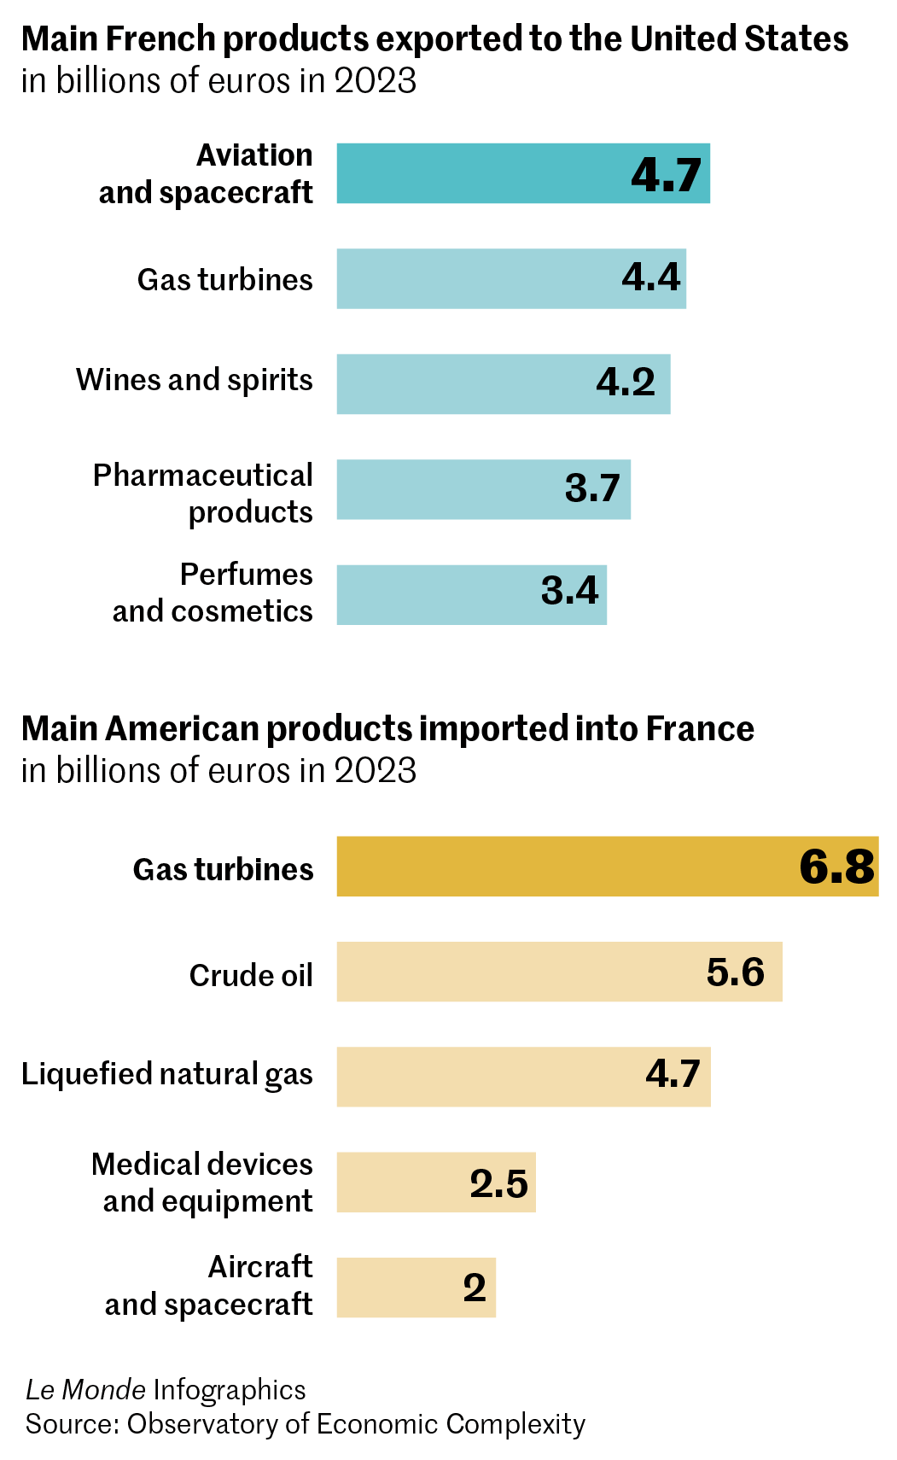

Aeronautics
One-fifth of France's exports to the US are related to aeronautics. France exported €9 billion worth of "aircraft and spacecraft" to the US in 2024.
The European aircraft manufacturer Airbus, with its operational headquarters located in Blagnac, a suburb of Toulouse, claims to be the leading client of American aerospace industry exports. "We have taken note of the announcements and are assessing the potential impacts," an Airbus spokesperson told Agence France-Presse on Thursday. The company could be partially protected by its industrial presence in the US: It inaugurated a final assembly plant in Mobile, Alabama, in 2015, from which 500 A320 and A220 single-aisle aircraft had rolled out by the end of 2024.
Airbus also pointed out that it purchases more than $15 billion worth of parts each year from its approximately 2,000 American subcontractors, spread across 40 states, and claims to support 275,000 US jobs. Its American industrial footprint is expected to increase further in 2025 with the planned inauguration of a second final assembly line for the A320, which will create "1,000 new jobs" in the Gulf of Mexico region.
Dassault Aviation, a French aircraft manufacturer that sells between one-third and half of its private jets to the US, had announced at the beginning of March that its 2025 financial forecasts largely depended on the level of US tariffs.

Luxury goods (perfumes, toiletries, and leather goods)
goods, highly prized in the US, are necessarily exports.
Among the major French brands, LVMH owns production sites in the US, where it generates a quarter of its revenue. The luxury clientele, often affluent, is less sensitive to price and thus to any potential increase in tariffs. "The company is almost 190 years old; we've experienced tariffs before," said Hermès luxury group's manager Axel Dumas in mid-February. "If tariffs increase, we will raise our prices to compensate," he said.

Pharmaceutical products
Pharmaceutical products also significantly contribute to French exports to the US: €3.6 billion in 2024. However, the White House announced in the evening that certain categories, including pharmaceuticals, were not affected by the new tariffs announced on Wednesday.

Wine and cognac
In 2024, approximately €2.4 billion worth of "grape wines" crossed the Atlantic to the US, in addition to more than €1.5 billion worth of "distilled alcoholic beverages," notably cognac. The French wine and spirits industry fears a decline of about €800 million in exports, according to a statement released overnight from Wednesday to Thursday.
Read more Subscribers only Trump tariff plans alarm French wine, spirits and dairy producers
According to Wednesday's announcements, Trump seems to have abandoned the idea of a 200% tax on European alcohols that he had considered in mid-March. The French Federation of Wine and Spirits Exporters still believes that the US decision to apply a general 20% tariff on all products imported from the European Union "will have extremely severe consequences on the French and European wine and spirits sector."
Le Monde
Translation of an original article published in French on lemonde.fr; the publisher may only be liable for the French version.

