https://www.lemonde.fr/en/economy/article/2023/05/12/northern-france-dreams-of-becoming-europe-s-battery-valley_6026479_19.html

Northern France dreams of becoming Europe's battery valley
The region is banking on electricity for its reindustrialization, with the launch of three gigafactory projects and a fourth one in the works.
By Florence Traullé (Lille, correspondante)
Published on May 12, 2023, at 5:24 pm (Paris), updated on May 14, 2023, at 8:35 pm
Subscribers only
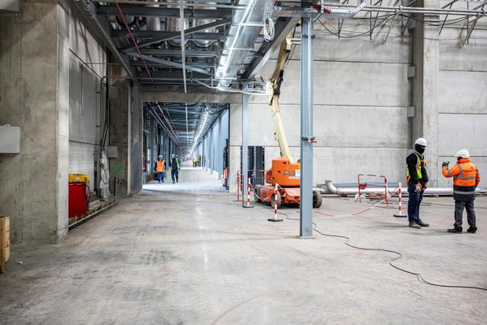 <img src="https://img.lemde.fr/2023/05/10/0/0/6720/4480/664/0/75/0/f7c1341_1683728807645-rea10097382.jpg" alt="On the ACC gigafactory construction site in Douvrin, northern France, on February 13, 2023."> On the ACC gigafactory construction site in Douvrin, northern France, on February 13, 2023. SIMONE PEROLARI / REA
French President Emmanuel Macron confirmed on Friday, May 12, the arrival of Taiwanese battery maker ProLogium in Northern France. The company will build a new factory in Dunkirk after auditing some 40 locations. For Macron, who visited the region on Friday, the news represents an opportunity to highlight his action in favor of the reindustrialization of the country. "This territory perfectly embodies our policy, with both a transformation of the actors in place and a strong attractiveness," the Elysée said. The presidency sees the announcement as the cornerstone of a sequence devoted to praising the government's pro-business efforts as well as its good economic results. "Our record is credible, that's what gives investors confidence," it said.
ProLogium, whose technology makes it possible to produce batteries with shorter charging times, plans to invest €5.2 billion and create 3,000 jobs by 2030. The company, which has already built its first mass production line in Taiwan, was considering France, Poland, the Netherlands and Germany for a second plant. Dunkirk, which has land available on its port site, has won. ProLogium plans to produce 50-60 gigawatt hours (GWh) on a 180-hectare site. This would be enough to equip 500,000-700,000 electric vehicles per year.
Dunkirk is known as one of the three "D" cities which, along with other northern municipalities of Douai and Douvrin, form the future battery valley that the region is to become. This will not be the region's first reindustrialization. After the closure of its mines and most of its steel industry, it has become the leading automotive region in France. Renault has three factories there, as does Stellantis, while Toyota has one, making up for 56,000 jobs in total. Now it aspires to make its mark on the European electric vehicle market.
The region is already home to all of France's gigafactory projects for the automotive industry. In Douvrin, ACC, a company operated by Stellantis, TotalEnergies and Mercedes, is running the most advanced of the three. The machines, installed in 1,800 containers and shipped from China and South Korea, went through the port of Dunkirk. ACC is aiming to produce 40 GWh per year by 2030 – enough to equip more than 500,000 electric cars – and promises to create 1,000-2,000 jobs in the longer term. The first batteries will leave the plant, scheduled to open on May 30, in September.

'Total gamble'
About 30 kilometers away, the China-Japan company Envision is setting up in Douai, next to the Renault factory. It will initially supply car batteries for Renault's next R4 and R5 cars and expects to create at least 1,000 jobs. French company Verkor, meanwhile, is expecting to create 1,500 positions at its plant, planned on the Zone grandes industries (Large Industries Zone) in the port of Dunkirk. In 2025, it is expected to produce 16 GWh (equipping 300,000 electric cars), then 50 GWh in 2030 (for one million cars). Verkor, a Grenoble-based start-up, has invested €500 million in a 100,000-square-meter plant.
And there is more. Jenlain, near Valenciennes, and Onnaing, close to the Toyota factory, are in the running to accommodate a car battery component factory. Alteo and South Korea's Wscope are contemplating putting €600 million on the table. With this project, the challenge for Northern France is to structure an entire ecosystem.
"It's a total gamble," said Xavier Bertrand, the region's president, adding that the local authorities – mainly the region but also other municipalities – injected "€60 million into Verkor, €60 million into Envision and €80 million into ACC." "And I am in discussions with major groups on graphite refining [which comes before battery production] and recycling. It's strategic to have the whole chain. We are in a decade of transformation. We need to be ahead of the game," Bertrand said.
"Our project is to remain the leading automotive region in France. The gigafactories' arrival is only the first stage. We then need to develop the entire industry that goes with it and as such, successfully complete the Hauts-de-France's industrial conversion, which has many assets: a port, major European highways, logistics infrastructures and proximity to England and Germany," said Luc Messien, a general delegate of the region's automotive industry association.

Training will be key
Bertrand's critics have expressed concern about the amount of public aid allocated to these plants, which, they believe, would only compensate for job losses related to the termination of the manufacture of internal combustion engines by 2035. "It will be much more than just job compensation," said Bertrand, who put the number of jobs linked to the electric battery at 15,000 within a 10-year horizon. Regional employers expect twice as many.
In a region where industrial wastelands are a handicap for local officials and where the unemployment rate – at 8.7% of the working population – is almost 1.5 points higher than the national average, everyone agrees on the challenge of recruitment and, consequently, training. "If companies can't recruit, they won't set up shop," Bertrand said. Even though "most of the jobs will be in manufacturing and industrial production, there are prospects for more skilled jobs," said Messien.
For instance, the Pas-de-Calais (one of the departments located in the region) research and development center in Bruay-la-Buissière has just signed a contract with ACC that will provide it with 20% of its business for the next seven years. In the Lille area, the TND laboratory is working on the development of an innovative process to recycle lithium batteries.
The region has budgeted €10 million for training and is part of the Electro'Mob consortium, alongside the main car manufacturers in the Hauts-de-France region and the academic and university communities. A total of 40 partners have been teaming up to train more than 8,000 people in the electric car industry by 2030. The program has a budget of €25 million, including €14.2 million in government grants.
Florence Traullé (Lille, correspondante)
Translation of an original article published in French on lemonde.fr; the publisher may only be liable for the French version.

