https://www.lemonde.fr/en/economy/article/2025/03/06/germany-s-future-coalition-pledges-to-do-whatever-it-takes-to-boost-flagging-growth_6738879_19.html

Germany's future coalition pledges to do 'whatever it takes' to boost flagging growth
Berlin has acknowledged that its budget rules are no match for the double danger facing Germany: A significant threat to its security, and also a serious risk of economic collapse.
By Cécile Boutelet (Berlin (Germany) correspondent)
Published on March 6, 2025, at 12:36 pm (Paris)
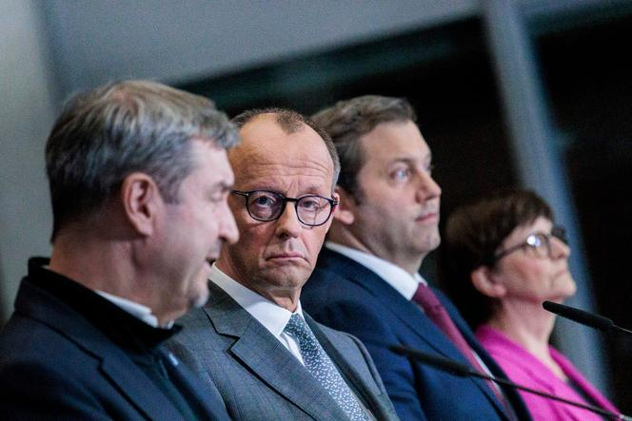 <img src="https://img.lemde.fr/2025/03/04/0/0/4500/3000/664/0/75/0/594e9da_ftp-import-images-1-64hef66eqgrr-7c511f0df9064e2cb3773a3aeaffd182-0-6ea3161041344de99c9d1bda0122fdef.jpg" alt="Friedrich Merz, the likely future German Chancellor, center, at a press conference in Berlin, March 4, 2025."> Friedrich Merz, the likely future German Chancellor, center, at a press conference in Berlin, March 4, 2025. CARSTEN KOALL / AP
It was an astonishing moment when, early in the evening on Tuesday, March 4, future chancellor Friedrich Merz − who until now had embraced 1990s economic dogma and budgetary discipline − uttered these words: "The rule for Germany's defense must be: 'Whatever it takes'." The Christian Democrat thereby adopted as his motto the famous words of former European Central Bank president Mario Draghi, who put an end to the euro crisis in 2012, announcing an accommodative monetary policy long reviled by German conservatives.
This belated tribute to the Italian has represented a historic break. Germany has recognized that its strict budgetary rules are no match for the double danger it faces: A significant threat to its security, at a time when the Americans no longer wish to guarantee European defense, and also a serious risk of economic collapse. Together with his likely future Social Democrat (SPD) coalition partners, Merz therefore announced a reform of the debt brake, eliminating this constitutional mechanism for limiting the deficit to 0.35% of gross domestic product (GDP) and exempting defense spending in excess of 1% of GDP from this rule.
Added to this is the creation, over the next 10 years, of a special fund worth €500 billion, to be used for renovation of infrastructure (roads, trains, schools) damaged by years of under-investment. The decision must still be approved by a two-thirds majority in the Bundestag on March 17.

Recession since 2023
Like Draghi in 2012, Berlin has sent economic players a signal of strength, which is expected to have major macroeconomic consequences. Nine hundred billion euros will be injected into the economy over the next few years. In an analysis published on Wednesday, March 5, ratings agency Moody's points out that the decision will have a significant effect on the debt ratio, which is set to rise by five percentage points by 2026 − it currently stands at 62% of GDP. But "such an increase in spending would support economic growth beyond 2026, Germany's main credit constraint," added the agency, which also felt that the announced legislative package has sent "a positive signal" about the future coalition government's ability to implement decisive policies.
The German economy has been in deep stagnation since 2019, and in recession since 2023, with bankruptcies and relocations accelerating, unemployment rising above the 3-million mark and investors losing interest. The investment plan announced on Tuesday, could halt the negative momentum, according to economist Sebastian Dullien, who thought that the project would "lift Germany out of stagnation and produce a massive change in the morale of the economic players." The DAX, the Frankfurt Stock Exchange's main index, jumped 3.6% on Wednesday, buoyed in particular by the upturn in arms stocks.
The BDI, Germany's federation of industries, welcomed the legislative package on Wednesday morning. "It's an important signal to the economy that things are moving forward," said Tanja Gönner, co-president of the BDI. "Germany is back," said Sander Tordoir, chief economist at the Centre for European Reform.

Jens Südekum, professor of economics at the University of Düsseldorf and co-author of the reform proposal, anticipated that the fiscal stimulus would not only produce a "medium-term growth spurt," but also a "paradigm shift": "It's a clear signal to private-sector companies to develop the capacity for renovating roads, railroads and bridges. This also applies to the defense sector," he told the weekly Die Zeit.
The unexpectedly far-reaching plan also triggered anger from the liberal and conservative camps, some of whose representatives rightly argued that Chancellor Merz has made a 180-degree turn from his campaign promise of structural reforms and less red tape for investment, not more debt. Will Germany have the courage to undertake the necessary economic reforms now that the financial pressure has been lifted? On Wednesday, the economic debate was dominated by concerns over rising inflation, debt-repayment arrangements and the slump in value of German bonds, historically seen as safe investment. Just like back in the days of the euro crisis.
Cécile Boutelet (Berlin (Germany) correspondent)

