Meloni's deficit reduction masks Italy's struggling economy
While Rome boasts of ratings agencies upgrading its public debt, Italy's economy continues to suffer from sluggish growth, anemic productivity, persistent poverty and a continuing brain drain.
By Allan Kaval (Rome (Italy) correspondent)
Published on September 30, 2025, at 8:00 pm (Paris)
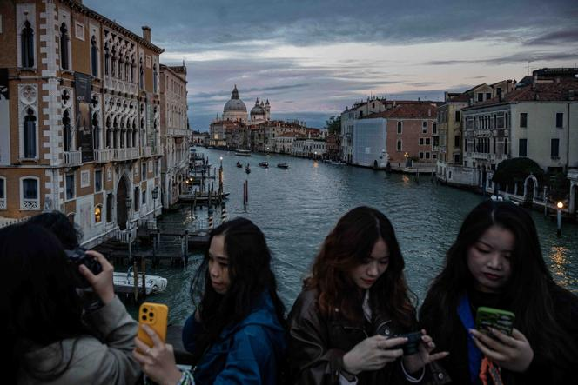
From the outside, Giorgia Meloni's Italy appears to be a prosperous island of certainty in a Europe on shaky ground. France is mired in a tangle of crises, and Germany surpassed the three million unemployed mark in August. Meanwhile, on September 18, Italy's 10-year borrowing rates fell to match those of France, reflecting a dramatic drop in the public deficit from 7.2% of gross domestic product (GDP) in 2023 to 3.4% in 2024.
By contrast, France, with a 5.8% GDP deficit, saw its debt rating downgraded from AA− to A+ by ratings agency Fitch on September 12. On September 19, Fitch upgraded Italy's rating from BBB to BBB+. Meloni immediately welcomed this as "confirmation that the path of my government is the right one."
Her government, one of the most stable in Italy's history, celebrated, while in France, people are debating the so-called "Meloni model." On the right and beyond, many readily praised the merits of this conservative, illiberal and nationalist government's methods in addressing today's challenges. "In the most difficult circumstances, the budget deficit ended up lower than expected, and it is no longer taboo to hope for full employment. Italy has regained its credibility: It is an anchor of stability for Europe. Growth will follow from this foundation," said Domenico Lombardi, a former economist at the Banca d'Italia and professor of public policy at Rome's Luiss University. Italy's economy grew 0.7% in 2024, slightly below the eurozone average of 0.8%, and is forecasted to drop to 0.6% in 2025, according to forecasts from the Organization for Economic Co-operation and Development (OECD), versus 1.2% for the European average.
"The economy is like the weather: What matters is how it feels," said a French lobbyist familiar with the corridors of power in Rome and Milan, speaking on condition of anonymity. But in this case, the gap with the actual temperature is significant. Italy's fiscal turnaround was driven by one-off measures and external factors: about €194 billion in European funds available as part of the post-Covid-19 recovery plan, and an improved labor market, with unemployment at 6% in July (slightly below the European average), which boosted public revenues. Beyond these factors – none of which resulted from reforms – the Italian economy continues to suffer from weaknesses that policies since 2022 have yet to address, if not ignored outright.
The country is experiencing an irreversible demographic decline, exacerbated by the emigration of educated Italians. Those who remain face low wages, high job insecurity and persistent poverty. Moreover, the impressive drop in the public deficit has concealed the lingering effects of past crises on a debt that stood at 135.3% of GDP in 2024, set to rise to 136.7% in 2025 and potentially to 138.5% by 2027, before falling back to 134% in 2030, according to Fitch. "We are talking about a change of image, not of economic policy," argued Francesco Papadia, a senior expert at the European research center Bruegel. "For growth, fiscal seriousness is not a substitute for real reforms that would reduce debt – reforms this government has not even considered."

Low labor productivity
Although the banking sector is healthy, Italy has seen industrial production decline in recent months, followed by a slight upturn in the summer, leaving economic players and observers unenthusiastic. Even in industrial Bergamo, Lombardy, doubts persist. Gian Paolo Negrisoli, president and son of the founder of the pharmaceutical company Flamma, which has a strong presence in China and total revenue of €200 million, put it bluntly: "I don't see any industrial policy. The government hasn't done anything to cut red tape or help us invest productively in the country. We're used to working without Rome."

Echoing a consensus among industrialists who face the highest energy costs in Europe, Negrisoli offered a critical view of the "Transition 5.0" plan, launched by the government in 2024 and set to run through 2026, which provides tax credits too complex to implement. This view was shared by Massimiliano Cacciavillani, head of Lovato, a family-run electrotechnical firm founded in 1922: "Industrialists are left to fend for themselves in an uncertain climate while Europe falls behind."
The difficulties persist. Chief among them is Italy's major problem: low labor productivity, estimated by the OECD at $79.34 (€65.60) per hour in 2024. This is higher than Spain ($77.76), but much lower than France ($90.86). Studies by the European Commission show that Italy's productivity level fell further in 2024. This weakness is attributed to a slow justice system, the small size of companies with little innovation and insufficient research and development spending. The post-Covid recovery plan, scheduled to end in late 2026 and intended to spur growth through major infrastructure projects and administrative modernization, has yet to yield its full results. Despite being Europe's second-largest manufacturing power, Italy ranked only 14th among member states for innovation in 2025, according to the Commission.
The peninsula also suffers from protected rents shielded from competition, such as those for beach clubs, taxis and notaries. Although this is a central issue, "the debate is distorted by the influence of sectoral lobbies," said a senior civil servant specializing in public finance, speaking on condition of anonymity. Beyond these rents, fiscal favoritism is strong. In 2023, Meloni compared some previous governments' tax measures targeting small retailers to a "state pizzo," using a term commonly associated with mafia extortion. Her government therefore lowered the tax burden on small businesses and the self-employed, claiming it would boost hiring. "The self-employed and small entrepreneurs form the core of the right-wing electorate and currently benefit from a flat-rate regime that encourages tax evasion more than growth," said Andrea Roventini, an economist at the Scuola Superiore Sant'Anna in Pisa.

'Rent spiral'
The social climate is also deteriorating. The 2024-2025 report from the International Labour Organization, published in February, shows that Italy is one of the few G20 countries where wages remain below their 2008 level. This flaw is all the more glaring in a country without a minimum wage. The drop in unemployment from 7.8% in 2022 to 6% in 2024 also masks a rise in the number of working poor and in involuntary part-time work, which primarily affects women. As a result, the number of families in absolute poverty remains above 8 million, while the share of the population at risk of poverty stood at 23.1% in 2024.
The end of the citizens' income, which Meloni announced would be scrapped on May 1, 2023, made matters worse. The program had lifted one million people out of absolute poverty. "Socially, Italy also holds together thanks to its elderly, who make up the difference with savings and wealth accumulated in the past," explained Luca Giunti, an analyst at the public policy research center Openpolis, noting that support from the "providential family" acts as the last social safety net for many struggling young people. "But the savings made in the 20th century could eventually dry up in the long run," he added.
Not for everyone, however. Giacomo Gabbuti, an assistant professor at the Scuola Superiore Sant'Anna in Pisa, who edited the book Non è giusta. L'Italia delle disuguaglianze ("It's Not Fair: Italy's Inequalities"), said: "In Italy, wages are falling, but real estate and financial wealth have exploded in recent years, now reaching eight times GDP." The weight of these assets has entrenched inequality, while their low tax rate has created a "rent spiral" that diverts investment away from the productive economy. The economic historian pointed out that Italy's great fortunes stem from heirs of the 20th-century economic miracle, not from bold entrepreneurs.
According to the book, the devastating effects of climate change in Italy hit the poorest hardest – those in fragile housing with limited access to insurance. This finding came as Rome shifted its focus toward a renewed emphasis on fossil fuels, including oil, at the expense of renewables.
Economist Emanuele Felice sees in this a reflection of the "extractivist" trend championed by the Trump administration, one that also includes tourism – considered the quintessential rent and, in a 1990s expression, "Italy's oil." While tourism posts strong growth, it has led to the gentrification of city centers and the spread of precarious, low-paid jobs in a country where every major city seems headed toward the nightmare of Venice, ravaged by mass tourism. Asked about Italy's prospects, Roventini commented: "Today's Italy is like 18th-century Venice. Sublime, wealthy, but stagnant. Ready to fall." Still, it can count on fragile neighbors and flattering comparisons.
Allan Kaval (Rome (Italy) correspondent)
Translation of an original article published in French on lemonde.fr; the publisher may only be liable for the French version.

