Internship Competency Planning Form

Note: Throughout this document, the masculine gender is used generically to refer to any person, regardless of their gender.
Student: | Last Name: …………………………………… |  |  | First Name: …………………………………… |  |  |  | Service des Stages
Year - Spec: 4th year GBM |  |  | Internship Dates: ……………………… to ……………………….
Host Organization: …………………………………………………………………………………………………….
Internship Subject: …………………………………………………………………………………………………… |  |  |  |  |  |  |  | Phone: +33 (0)4 72 43 17 77
……………………………………………………………………………………………………………………………….. |  |  |  |  |  |  |  | entreprise@polytech-lyon.fr
Supervisor: ………………………………………………………………………………………………………………
Dept. / Position: ………………………………………………………………………………………………………………………………………………………
Email: ………………………………………………………………………………………………… |  |  |  |  |  | Phone: …………………………………………………..
Academic Advisor: …………………………………………………………………………………………………………………………………………………
Email: ………………………………………………………………………………………………… |  |  |  |  |  | Phone: …………………………………………………...
Date: |  | Student’s Signature: |  |  | Host Org. Supervisor’s Signature: |  | Academic Advisor’s Signature:
Please return this form by email to the Academic Advisor by the end of the 1st month of the internship
This document is designed to enable the intern and their host organization supervisor to jointly define, on a provisional basis at the very beginning of the internship, the elements of the educational Competency Framework (competencies and associated key learnings, see Appendix on the last page) that will be utilized and assessed during the work placement.
For each competency developed during the internship (a minimum of one out of the 4 competencies in the framework), the tables should be completed as follows:
- Table 1: Competency addressed during internship: in the left-hand column, please check the box only if the competency will be utilized and developed during the internship. Student's Self-Perceived Competency: in the right-hand columns, the student should indicate their current self-assessment regarding this competency and its key components. A guide to help with positioning across the different levels is available in the appendix, on the last page of this document.
- Table 2 - Key learnings for the internship: for each selected competency, also check the associated key learnings that will be utilized during the internship to allow the competency to be exercised in context, based on the missions and tasks constituting the internship program.
Example - If the internship aims to develop, among others, Competency C1 " Designing Medical Devices":
➔ Table 1: The competency is checked in the left-hand column. - The student indicates their current self-perceived competency regarding C1 and its key components in the right-hand columns. Table 2 - The student and the supervisor jointly select the key learnings for Competency C1 that are planned to be utilized during the internship
Table 1: Competencies and Key Components |  | Table 2: Key Learnings
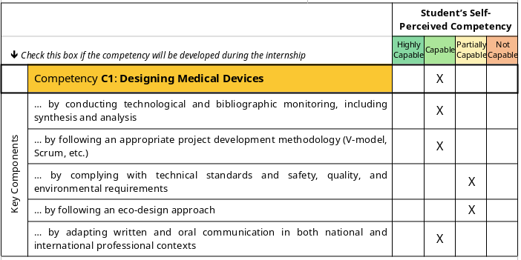 |  | 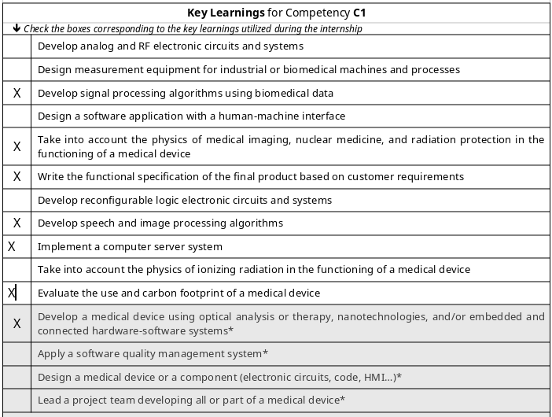
 |  |  | Student’s Self-Perceived Competency
⬇ Check this box if the competency will be developed during the internship |  |  | Highly Capable | Capable | Partially Capable | Not Capable
 | Competency C1: Designing Medical Devices
Key Components | … by conducting technological and bibliographic monitoring, including synthesis and analysis
Key Components | … by following an appropriate project development methodology (V-model, Scrum, etc.)
Key Components | … by complying with technical standards and safety, quality, and environmental requirements
Key Components | … by following an eco-design approach
Key Components | … by adapting written and oral communication in both national and international professional contexts
Key Learnings for Competency C1
⬇ Check the boxes corresponding to the key learnings utilized during the internship
 | Develop analog and RF electronic circuits and systems
 | Design measurement equipment for industrial or biomedical machines and processes
 | Develop signal processing algorithms using biomedical data
 | Design a software application with a human-machine interface
 | Take into account the physics of medical imaging, nuclear medicine, and radiation protection in the functioning of a medical device
 | Write the functional specification of the final product based on customer requirements
 | Develop reconfigurable logic electronic circuits and systems
 | Develop speech and image processing algorithms
 | Implement a computer server system
 | Take into account the physics of ionizing radiation in the functioning of a medical device
 | Evaluate the use and carbon footprint of a medical device
 | Develop a medical device using optical analysis or therapy, nanotechnologies, and/or embedded and connected hardware-software systems*
 | Apply a software quality management system*
 | Design a medical device or a component (electronic circuits, code, HMI…)*
 | Lead a project team developing all or part of a medical device*
* Key learnings appearing in greyed-out boxes correspond to the 5th-year internship level. However, for this 4th-year internship, they may be included in the assessment if they are expected to be significantly mobilized within the scope of the assigned tasks.
Comments

 |  |  | Student’s Self-Perceived Competency
⬇ Check this box if the competency will be developed during the internship |  |  | Highly Capable | Capable | Partially Capable | Not Capable
 | Competency C2: Managing the Medical Device Fleet in a Healthcare Facility
Key Components | … by adapting to the needs of healthcare professionals (doctors, nurses, caregivers, etc.)
Key Components | … by justifying purchasing processes in line with institutional policy
Key Components | … by complying with preventive and corrective maintenance processes
Key Components | … by optimizing the equipment lifecycle
Key Components | … by complying with technical standards and safety, quality, and environmental criteria
Key Components | … by adapting communication within a multidisciplinary professional context
Key Learnings for Competency C2
⬇ Check the boxes corresponding to the key learnings utilized during the internship
 | Perform electrical measurements (commissioning, maintenance, troubleshooting…) on medical devices
 | Comply with usage, installation, and maintenance requirements of medical imaging and nuclear medicine systems
 | Understand the structure of a hospital system, particularly a biomedical department
 | Collaborate within diverse and multidisciplinary teams
 | Configure technical platforms in healthcare facilities
 | Use planning, monitoring, and maintenance tools (e.g., CMMS software)
 | Conduct normative and competitive technology monitoring of a medical device line
 | Commission a specialized equipment line
 | Configure imaging and biology laboratory technical platforms*
 | Use risk management and materiovigilance analysis tools*
 | Design an investment program aligned with the institution's economic, ethical, societal, and legal issues*
 | Draft a call for tenders*
 | Make decisions under uncertainty based on available information*
* Key learnings appearing in greyed-out boxes correspond to the 5th-year internship level. However, for this 4th-year internship, they may be included in the assessment if they are expected to be significantly mobilized within the scope of the assigned tasks.
Comments

 |  |  | Student’s Self-Perceived Competency
⬇ Check this box if the competency will be developed during the internship |  |  | Highly Capable | Capable | Partially Capable | Not Capable
 | Competency C3: Supporting the Commercialization and Commissioning of Medical Devices
Key Components | … by complying with the specifications expressed by or for the client
Key Components | … by using technical and documentary standards aligned with the state of the art
Key Components | … by adhering to technical, safety, quality, and environmental norms
Key Components | … by adopting an appropriate commercial or training approach with clients
Key Components | … by adapting communication in international and intercultural contexts
Key Learnings for Competency C3
⬇ Check the boxes corresponding to the key learnings utilized during the internship
 | Analyze the functioning of major physiological systems to understand the principle and use of medical devices
 | Gather and understand the expectations of healthcare professionals within a global vision of a healthcare facility
 | Conduct technological and regulatory monitoring
 | Perform a comparative and critical analysis of a medical device line
 | Draft documentation (in any format) for a medical device for commercial purposes
 | Use a specific medical device (or its associated line) after manufacturer training
 | Establish professional rapport with stakeholders
 | Identify purchasing circuits and processes*
 | Estimate the budget and return on investment for a medical device*
 | Apply negotiation methods during a purchase, from both seller and buyer perspectives*
 | Manage customer relationships from pre-sales to post-sales for a medical device*
 | Perform product demonstrations for specific medical devices after manufacturer training*
* Key learnings appearing in greyed-out boxes correspond to the 5th-year internship level. However, for this 4th-year internship, they may be included in the assessment if they are expected to be significantly mobilized within the scope of the assigned tasks.
Comments

 |  |  | Student’s Self-Perceived Competency
⬇ Check this box if the competency will be developed during the internship |  |  | Highly Capable | Capable | Partially Capable | Not Capable
 | Competency C4: Ensuring Medical Devices Comply with Quality and Regulatory Requirements
Key Components | … by contributing to the quality policy in line with regulatory constraints
Key Components | … by participating in the development of product specifications
Key Components | … by conducting document monitoring to anticipate changes in standards and legislation
Key Components | … by adapting communication in an international and interdisciplinary context
Key Components | … by demonstrating responsibility, ethics, and professional conduct
Key Learnings for Competency C4
⬇ Check the boxes corresponding to the key learnings utilized during the internship
 | Use statistical analysis tools for quality and certification
 | Apply ethical analysis frameworks by distinguishing empirical questions from value judgments
 | Analyze data for statistical purposes
 | Develop control, compliance, and quality assurance tools
 | Use metrology and monitoring tools (dashboards, KPIs)
 | Analyze quantitative and qualitative data to evaluate and improve service quality*
 | Apply quality procedures in institutions (HAS accreditation v2010)*
 | Apply regulatory affairs in the field of medical devices and medical imaging platforms*
 | Use quality management standards (ISO 9001) and those specific to medical devices (ISO 14971, ISO 13485)*
 | Perform CE marking and compile the technical documentation*
 | Assist with and follow up on accreditation or certification application processes*
* Key learnings appearing in greyed-out boxes correspond to the 5th-year internship level. However, for this 4th-year internship, they may be included in the assessment if they are expected to be significantly mobilized within the scope of the assigned tasks.
Comments

APPENDIX
Competency-Based Approach and Competency Framework: The Essentials
This Competency Planning Form is part of the Competency-Based Approach (in French: Approche par Compétences, APC), an educational methodology designed to assess a future engineer's ability to act effectively in real-world professional situations. This approach relies on a Competency Framework, a structured guide defining the key "complex abilities to act" that students must master by the end of their program.
For the Polytech Lyon Materials program, this framework consists of 4 Competencies (C1 to C4), which are representative of a Materials Engineer's activities and are linked to the Competency Blocks of the RNCP fiche 39916. The internship offers a prime opportunity for students to mobilize and develop one or more of these competencies in a professional setting.
The main elements of this framework fall into 3 categories:
- Competency: this is a "complex ability to act" that enables an individual to perform effectively in a given situation by appropriately mobilizing and combining various resources (knowledge, know-how, soft skills/attitudes). Unlike a simple skill, a competency involves adapting to the specifics of situations and contexts by making justified choices.
- Key Components: also known as "performance criteria for a competency," these are the specific criteria that describe the expected quality of action when the competency is implemented. They generally specify the resources to be mobilized, the rules or constraints to be respected, the methodological approaches, communication methods, and the quality of the outcome.
- Key Learnings: these are the essential learnings absolutely necessary for the exercise of a competency. They involve mobilizing multidisciplinary resources of various kinds (knowledge, know-how, soft skills/attitudes).
Self-Perceived Competency (Sentiment de compétence)
This refers to the student's subjective feeling, at a given point in their program, regarding their mastery of a competency and its key components.
Guide to Assessing Self-Perceived Competency
Highly Capable | "I feel very comfortable with this competency. I believe I can act autonomously and even take initiative in most situations, including new or complex ones. I generally have a good idea of the knowledge and skills needed to achieve excellent results."
Capable | "I think I have a good grasp of this competency. In typical situations, I feel I can act mostly autonomously using the right resources. I should be able to adapt, justify my choices, and achieve the expected results."
Partially Capable | "I'm currently in the process of acquiring this competency. I think I can act in certain situations, but I know I might face difficulties in fully mobilizing the necessary resources or adapting to specific contexts. I'll likely need frequent guidance to perform well and justify my actions."
Not Capable | "At the moment, I don't feel comfortable with this competency at all. I would find it very difficult to act in the relevant situations or to mobilize the necessary knowledge and skills. I think I would need major help to accomplish anything in this area."
Additional Advice for Students:
- Be honest with yourself: the goal is to establish a starting point to better assess your progress.
- Think about your past experiences: previous internships, academic projects, and personal experiences can offer guidance.
- Don't overestimate or underestimate yourself; try to find a fair balance. It's perfectly normal not to feel "Capable" (let alone "Highly capable") in all areas at the beginning of your internship.
- If you have significant doubts, your Academic Advisor can help you reflect on your self-assessment.

