Lil’ Poundcake
1° Watch video and collect information.

- Title
- Author(s)
- Date
- Keywords
- Genre
- Plot or topic
- Tone
- Issue(s)

- Outcome
- Possible application
- Potential risks
- New voc.
- Personal opinion

Vocabulary you may find helpful to talk about a video:

□ a spoof
□ a documentary
□ a segment on the news
□ a mockumentary
□ an extra-feature on a DVD
□ a scene from a movie
□ an excerpt
□ a parody
□ an extract
□ a snippet
□ a skit
□ a bonus on a DVD

2° Read the post below to learn a bit more about what triggered it.
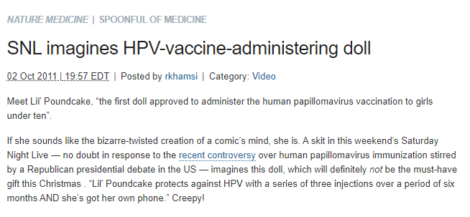

3° Do you think humour in a health campaign is appropriate ? Effective? Easily understood? Discuss this with 2 classmates and write a short statement containing your opinion and an example.

