Written exam: RAAC in Hospitals
Name
Grade /20 |  | CEFR level

- Reading comprehension
Article 1: NHS patients at risk as hospital urgent repair costs triple in decade, by Michael Savage, The Guardian (Sat 28 Dec 2024)

Cost of maintenance backlog has increased dramatically since 2015 and health service lost 600 days of clinical time to related incidents in the past year.
A decade-long failure to address urgent repairs in hospitals across England has led to a dramatic rise in issues posing a “high risk” to patients and staff, ministers are being warned.
The cost of dealing with this backlog has almost tripled since 2015 in real terms, to £2.7bn this year. High-risk repairs have been the fastest growing part of the lengthy maintenance list over that time. It includes issues that could lead to serious injury to both staff and patients, or to major disruption of services or “catastrophic failure”.
The NHS lost more than 600 days – or 14,500 hours – of clinical time because of infrastructure failures in the last year, according to a new analysis seen by the Observer. The total maintenance backlog has now ballooned to £13.8bn in 2023-24, an 18% increase from last year. The figure is more than the NHS’s entire capital budget for the year.
There were 22 incidents of lost clinical time a day on average, according to the analysis of official data by the House of Commons library. Close to 80% of the time lost was due to incidents deemed to have the most clinical impact, including faulty roofs, water leaks, and broken lifts or heating systems. There were 1,584 “critical incidents” recorded, the most severe kind.
Helen Morgan – the Liberal Democrats’ health and care spokesperson who commissioned the House of Commons library to review data on the hospital repair backlog – blamed the “shocking figures” on years of neglect.
“Patients are no longer confident that desperately needed treatment will go ahead without being interrupted by hospitals crumbling around them,” she said. “How can the government expect to get the NHS waiting times down when the buildings are in such a state of disrepair? It is a situation that the new government must grip urgently and bring to an end.
“That should start by ministers bringing forward a 10-year plan to eradicate the repair backlog and ensure that our NHS is fit for purpose so that patients can finally get the care they deserve.”
Essex Partnership University NHS trust recorded 300 critical incidents in 2023-24, the most of any trust in England. It said it was having to manage more than 200 sites in partnership with other providers. It is now focusing on a programme of refurbishment of inpatient wards, investing £20m since 2020.
Princess Alexandra Hospital NHS trust recorded 229 critical incidents. Tom Burton, its director of finance, said the trust continued to face challenges as a result of an “ageing estate”, including electrical issues and older systems. The trust is prioritising maintenance that ensures compliance with health and safety standards and improves resilience of its infrastructure.
The rise in severe maintenance problems is worrying NHS experts. “We’re seeing faster growth in the higher risk categories, where the consequences of not doing that maintenance would be more substantial,” said Katie Fozzard, an economist at the Health Foundation. “The highest risk category has almost tripled since 2015.”
Rory Deighton, acute network director at the NHS Confederation, said the increasing amount of clinical time lost to disrepair across the NHS was “very concerning” and warned it was the result of long-term underfunding. “Healthcare leaders know first-hand the impact that crumbling buildings and outdated equipment is having on the care they and their staff can provide to patients,” he said. “This is a direct result of the dearth of capital invested into the NHS over the last 10 years or more.
“Greater investment in NHS estate, buildings and kit is desperately needed given the maintenance bill for these buildings, and this infrastructure is now higher than the allocated capital budget as a whole. We need to simultaneously fix the broken and run down, but also build and modernise for the future, including in the technology and digital equipment required.”
He also called for an overhaul of the bureaucracy that often held up the plans of hospital bosses to deal with the essential repair and modernisation work. “The process of getting the funding that does exist out to the frontline needs urgently simplifying,” he said.
Charles Tallack, director of research and analysis at the Health Foundation, warned that the poor condition of the NHS estate was hampering efforts to make the service more efficient. “NHS productivity has declined,” he said. “There’s been at least a 20% increase in hospital staff since before the pandemic, but we’ve seen nowhere near that increase in hospital activity.
“Part of the reason is that we’ve not invested sufficiently in maintaining buildings, so the extra staff aren’t being used as well as they could be. There are some really stark examples of this. If you have theatres with leaking roofs or under water, then staff can’t get on with caring for patients.”
The government is now investing £1bn to tackle the existing backlog of critical maintenance. While the Tories had pledged to build 40 new hospitals under the new hospitals programme, the scheme was widely criticised for failing to provide the necessary funds to deliver it. The Labour government is now reviewing the programme and is prioritising hospitals built using reinforced autoclaved aerated concrete (Raac), now deemed a serious risk.
A Department of Health and Social Care spokesperson said: “Buildings and equipment across the NHS have been left to crumble following years of neglect, disrupting patient care and hindering staff. We are investing over £1bn to tackle the existing backlog of critical maintenance, repairs and upgrades. Repairing and rebuilding our NHS estate will be a vital part of our 10-year health plan.”

Article 2: Motts to review NHS hospitals blighted by RAAC concrete crisis, by Rob Hakimian, New Civil Engineer (13 Jul, 2022)

The Treasury and the Department of Health and Social Care have hired Mott MacDonald to carry out a review into hospitals that are at greatest risk of collapse due to being built from reinforced autoclaved aerated concrete (RAAC).
RAAC is ‘borrowed’ technology from other industrial processes that speeds up the manufacturing turnaround of precast concrete units and was used in schools and hospitals between the 1960s and 1990s. However, there is a high volume of air within RAAC, making it vulnerable to moisture ingress and it is now known to lose tensile strength in situ.
A sudden ceiling collapse at a primary school in Essex in 2018 brought the issue to light. It has seen the NHS implement emergency supports and monitoring systems on seven badly affected hospitals around the country that have been built with RAAC.
The government has previously committed £110M for temporary safeguarding of these hospitals, and Mott MacDonald will now review each of them to ascertain their condition and what works will be needed to make them permanently safe.
NHS England and Improvement has put out a directive stating that all RAAC must be eliminated from NHS hospitals by 2035. It has ring-fenced funds for resolving RAAC issues, to be distributed on a bespoke basis dependent on the risk assessment carried out by Mott MacDonald.
In the meantime, the NHS has started carrying out simulations of evacuations should a ceiling collapse occur. In that event, a national incident would be declared, forcing patients and services to be moved to other parts of the country.
One of the worst affected is Queen Elizabeth hospital in King’s Lynn, where there are reportedly 1,500 steel props holding up the ceiling in 56 different areas. There is a team of 12 checking the safety of the building 24 hours a day, seven days a week.
The Queen Elizabeth Hospital Kings Lynn NHS Trust chief executive Caroline Shaw told The Times: “The roof is like is like a chocolate Aero bar. There are bubbles in the concrete and we’re checking it daily to make sure those bubbles don’t break, and the roof doesn’t come down. It really is like a ticking time bomb. We quite often have to move services around to enable us to prop the roof and I think for patients who are lying in bed and seeing these props it does feel quite unsafe and we do have patients complain about this.”
The trust has now submitted a bid for £862M to tear down and rebuild the site.
It follows in the footsteps of Frimley Park Hospital in Camberley, another of the worst affected by RAAC, where the Frimley Health NHS Foundation Trust has recently put in a bid for £1.26bn to rebuild the hospital.

- Are the statements true or false? Support your choice with a quote. (l. + quote) /5
a/ The cost of the NHS maintenance backlog has nearly doubled since 2015.  Line + quote: | □ T □ F
b/ The NHS lost over 600 days of clinical time in the past year due to infrastructure failures.  Line + quote: | □ T □ F
c/ RAAC concrete was commonly used in NHS hospitals from the 1960s to the 1990s.  Line + quote: | □ T □ F
d/ Mott MacDonald has been hired to design new hospitals to replace those affected by RAAC.  Line + quote: | □ T □ F
e/ The Queen Elizabeth Hospital in King’s Lynn requires over 1,500 steel props to support its roof.  Line + quote: | □ T □ F

- Vocabulary /10
Match words from the text with their definition (in the right order).
- (n.) a delay in completing tasks or dealing with requests → __________________
- (v.) to suddenly and rapidly increase in size or amount → __________________
- (n.) a part of a hospital where patients stay overnight → __________________
- (n.) lack or shortage of something necessary → __________________
- (v.) to promise or commit to doing something → __________________
- (n.) unwanted entry of water or other substances → __________________
- (n.) the ability of a material to resist being pulled apart → __________________
- (n.) the process of protecting people from harm or danger → __________________
- (n.) the act of keeping money or resources for a specific purpose → __________________
- (adj.) custom-made for a specific purpose or user → __________________

- MCQ: Choose one correct answer. /5
1/ What is one of the main reasons for the NHS maintenance backlog's significant increase?
a) Lack of available construction companies
b) A rapid rise in the number of NHS patients
c) Long-term underfunding and neglect of infrastructure
d) New government policies limiting hospital repairs

2/ What type of incidents have caused the most clinical time loss in NHS hospitals?
a) Power outages due to external factors
b) Incidents related to faulty infrastructure, such as broken lifts and heating failures
c) Equipment shortages and supply chain delays
d) Poorly trained hospital staff causing operational inefficiencies

3/ Why is RAAC concrete considered dangerous in hospitals?
a) It absorbs excessive heat, making buildings unsafe
b) It was not designed to support large structures for long periods
c) It contains toxic chemicals that harm hospital staff and patients
d) It weakens over time due to its high air content and vulnerability to moisture

4/ How has the NHS responded to the risks posed by RAAC in hospitals?
- By closing all affected hospitals immediately
- By replacing all affected ceilings with traditional concrete structures
- By transferring all patients to private medical facilities
- By reinforcing vulnerable hospitals with steel props and conducting daily inspections

5/ What has been a key challenge in replacing RAAC in NHS buildings?
a) Hospitals are unable to close for repairs due to high patient demand.
b) The UK does not produce enough alternative building materials.
c) The government has banned all construction work in NHS facilities.
d) The technology to safely remove RAAC has not yet been developed.

- Summary: Write a condensed summary of both articles (+/- 100 words: 80-120). /10
______________________________________________________________________________________________
______________________________________________________________________________________________
______________________________________________________________________________________________
______________________________________________________________________________________________
______________________________________________________________________________________________
______________________________________________________________________________________________
______________________________________________________________________________________________
______________________________________________________________________________________________
______________________________________________________________________________________________
______________________________________________________________________________________________
______________________________________________________________________________________________
______________________________________________________________________________________________
______________________________________________________________________________________________
______________________________________________________________________________________________
______________________________________________________________________________________________

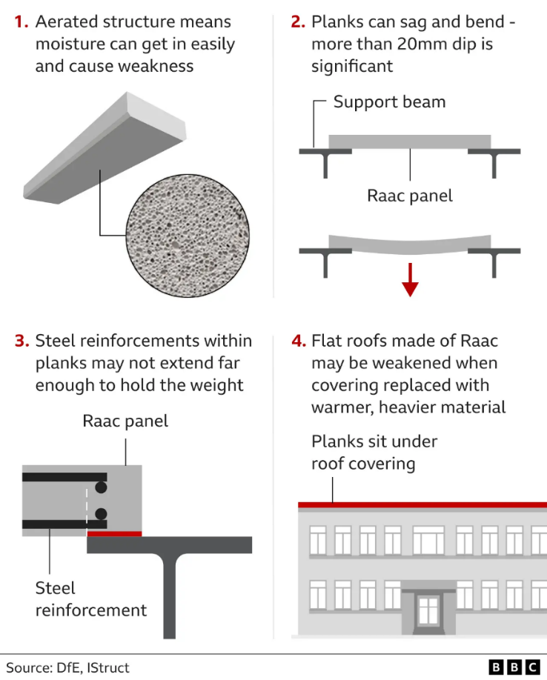
- Written task
In a structured essay (250-300 words), (1) explain the main risks associated with RAAC in hospital buildings and (2) propose one practical engineering solution to improve structural safety justifying why it would be effective.

_________________________________________________
_________________________________________________
_________________________________________________
_________________________________________________
_________________________________________________
_________________________________________________
_________________________________________________
_________________________________________________
_________________________________________________
______________________________________________________________________________________________
______________________________________________________________________________________________
______________________________________________________________________________________________
______________________________________________________________________________________________
______________________________________________________________________________________________
______________________________________________________________________________________________
______________________________________________________________________________________________
______________________________________________________________________________________________
______________________________________________________________________________________________
______________________________________________________________________________________________
______________________________________________________________________________________________
______________________________________________________________________________________________
______________________________________________________________________________________________
______________________________________________________________________________________________
______________________________________________________________________________________________
______________________________________________________________________________________________
______________________________________________________________________________________________
______________________________________________________________________________________________
______________________________________________________________________________________________
______________________________________________________________________________________________
______________________________________________________________________________________________
______________________________________________________________________________________________
______________________________________________________________________________________________
______________________________________________________________________________________________
______________________________________________________________________________________________
______________________________________________________________________________________________
______________________________________________________________________________________________
______________________________________________________________________________________________
______________________________________________________________________________________________
______________________________________________________________________________________________
______________________________________________________________________________________________
______________________________________________________________________________________________
______________________________________________________________________________________________
______________________________________________________________________________________________
______________________________________________________________________________________________
______________________________________________________________________________________________
______________________________________________________________________________________________
______________________________________________________________________________________________
______________________________________________________________________________________________
______________________________________________________________________________________________

