Abstract 1

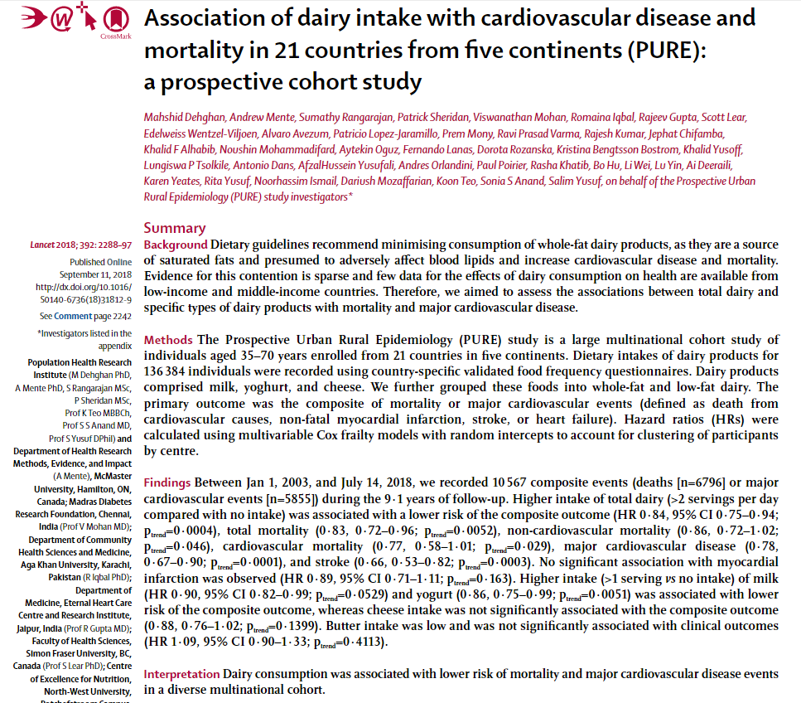

Abstract 2

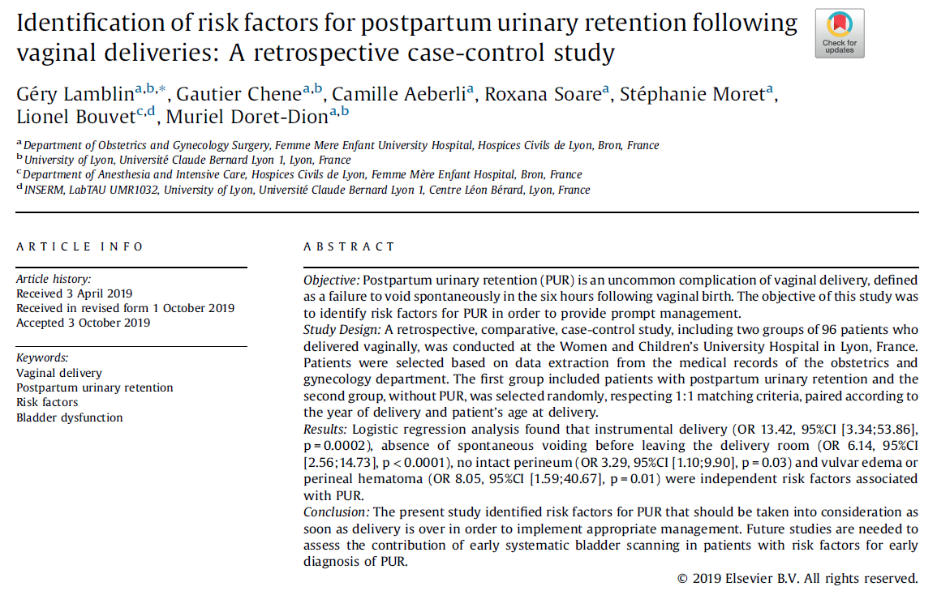

Abstract 3

JAMA. 2020 Aug 25;324(8):752-760. doi: 10.1001/jama.2020.12384.

Effect of Vitamin D3 Supplementation on Severe Asthma Exacerbations in Children With Asthma and Low Vitamin D Levels: The VDKA Randomized Clinical Trial

Authors
Erick Forno, Leonard B Bacharier, Wanda Phipatanakul, Theresa W Guilbert, Michael D Cabana, Kristie Ross, Ronina Covar, James E Gern, Franziska J Rosser, Joshua Blatter, Sandy Durrani, Yueh-Ying Han, Stephen R Wisniewski, Juan C Celedón

Abstract
Importance: Severe asthma exacerbations cause significant morbidity and costs. Whether vitamin D3 supplementation reduces severe childhood asthma exacerbations is unclear.
Objective: To determine whether vitamin D3 supplementation improves the time to a severe exacerbation in children with asthma and low vitamin D levels.
Design, setting, and participants: The Vitamin D to Prevent Severe Asthma Exacerbations (VDKA) Study was a randomized, double-blind, placebo-controlled clinical trial of vitamin D3 supplementation to improve the time to severe exacerbations in high-risk children with asthma aged 6 to 16 years taking low-dose inhaled corticosteroids and with serum 25-hydroxyvitamin D levels less than 30 ng/mL. Participants were recruited from 7 US centers. Enrollment started in February 2016, with a goal of 400 participants; the trial was terminated early (March 2019) due to futility, and follow-up ended in September 2019.
Interventions: Participants were randomized to vitamin D3, 4000 IU/d (n = 96), or placebo (n = 96) for 48 weeks and maintained with fluticasone propionate, 176 μg/d (6-11 years old), or 220 μg/d (12-16 years old).
Main outcomes and measures: The primary outcome was the time to a severe asthma exacerbation. Secondary outcomes included the time to a viral-induced severe exacerbation, the proportion of participants in whom the dose of inhaled corticosteroid was reduced halfway through the trial, and the cumulative fluticasone dose during the trial.
Results: Among 192 randomized participants (mean age, 9.8 years; 77 girls [40%]), 180 (93.8%) completed the trial. A total of 36 participants (37.5%) in the vitamin D3 group and 33 (34.4%) in the placebo group had 1 or more severe exacerbations. Compared with placebo, vitamin D3 supplementation did not significantly improve the time to a severe exacerbation: the mean time to exacerbation was 240 days in the vitamin D3 group vs 253 days in the placebo group (mean group difference, -13.1 days [95% CI, -42.6 to 16.4]; adjusted hazard ratio, 1.13 [95% CI, 0.69 to 1.85]; P = .63). Vitamin D3 supplementation, compared with placebo, likewise did not significantly improve the time to a viral-induced severe exacerbation, the proportion of participants whose dose of inhaled corticosteroid was reduced, or the cumulative fluticasone dose during the trial. Serious adverse events were similar in both groups (vitamin D3 group, n = 11; placebo group, n = 9).
Conclusions and relevance: Among children with persistent asthma and low vitamin D levels, vitamin D3 supplementation, compared with placebo, did not significantly improve the time to a severe asthma exacerbation. The findings do not support the use of vitamin D3 supplementation to prevent severe asthma exacerbations in this group of patients.
Trial registration: ClinicalTrials.gov Identifier: NCT02687815.

Abstract 4

